𝐆𝐫𝐚𝐢𝐧𝐏𝐚𝐥𝐞𝐭𝐭𝐞 – 𝘼 𝘿𝙚𝙚𝙥 𝙇𝙚𝙖𝙧𝙣𝙞𝙣𝙜 𝙊𝙙𝙮𝙨𝙨𝙚𝙮 𝙞𝙣 𝙍𝙞𝙘𝙚 𝙏𝙮𝙥𝙚 𝘾𝙡𝙖𝙨𝙨𝙞𝙛𝙞𝙘𝙖𝙩𝙞𝙤𝙣

Category: Artificial Intelligence

# Team Members and Roles

|  |  |
| --- | --- |
| Name | Role |
| N Leelakrishna | ML Model Developer |
| Motapotula Varalakshmi | Data Collection & Preprocessing |
| Mohammed Habeeb Pasha | Model Testing & Evaluation |
| Mohammad Faizul Rehaman | Documentation & Presentation |

# Introduction

## Purpose

The **GrainPalette** project aims to simplify and modernize rice grain identification using deep learning technology. By leveraging Convolutional Neural Networks (CNNs) and transfer learning through MobileNetV2, this AI-powered system can accurately classify different types of rice grains from images. The primary purpose of the project is to provide farmers, researchers, and home growers with a fast, user-friendly tool to identify rice varieties and make informed decisions about cultivation practices, such as irrigation, fertilizer use, and pest management. This contributes to smarter agriculture and promotes the adoption of AI in real-world farming scenarios.

## Key Features

•Accurate classification of five rice grain types using deep learning

• Image-based input for easy grain identification

• Real-time prediction with confidence scores

• Simple and user-friendly web interface

• Transfer learning with MobileNetV2 for efficiency

# Technical Details

## Programming Language

Python,HTML,CSS&JavaScript

## Machine Learning Algorithms Used

• Convolutional Neural Networks (CNN)

• Transfer Learning (MobileNetV2)

## Dataset Source

• Public rice grain image datasets

• Custom collected rice grain images

## Libraries and Frameworks

1. TensorFlow
2. Keras
3. Flask
4. OpenCV
5. NumPy
6. Pillow

## Tools and Platforms

1. Jupyter Notebook
2. Visual Studio Code
3. Git&GitHub
4. Google Colab (optional)
5. Localhost / Flask Server

# Technical Architecture

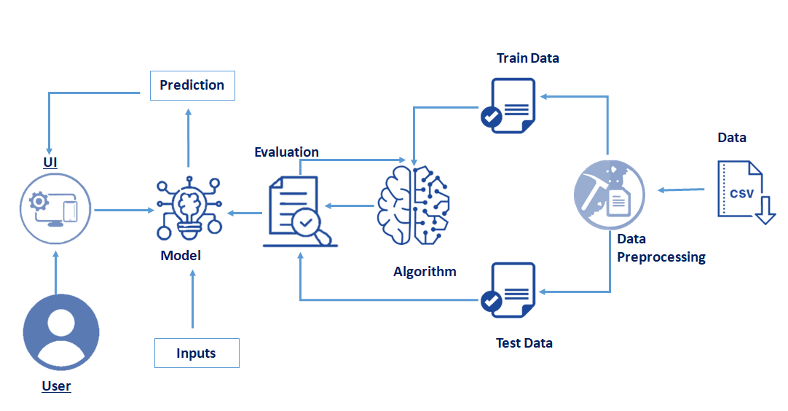

## Workflow Overview

• **Data collection and organization:** Gather and structure rice grain images by type for training and validation.

• **Data preprocessing and augmentation:** Resize, normalize, and augment images to improve model generalization.

• **Model building with MobileNetV2 transfer learning:** Use a pre-trained MobileNetV2 as the base model and add classification layers.

• **Model training and validation:** Train the model on the dataset while monitoring accuracy and loss.

•**Saving the trained model:** Export the final trained model for deployment.

• **Developing Flask backend for API:** Create a server to handle image uploads and return predictions.

• **Creating frontend for image upload:** Build a user-friendly web page for uploading rice grain images.

• **Integrating frontend and backend:** Connect the web interface with the Flask API for seamless prediction.

• **Running inference and displaying predictions:** Process user images and show rice type with confidence score.

• **Testing and evaluation:** Verify model performance on new images and improve if needed.

# Project Use Case Scenarios

Farmers' Crop Planning:  
Helps farmers identify rice seed types to optimize irrigation, fertilization, and pest management strategies.

Research and Agricultural Extension Services:  
Enables scientists and extension workers to rapidly classify rice varieties during field visits and research trials.

Home Gardening and Education:  
Assists home gardeners and students in exploring rice diversity and learning about different rice varieties for better cultivation.

## Output Screenshot

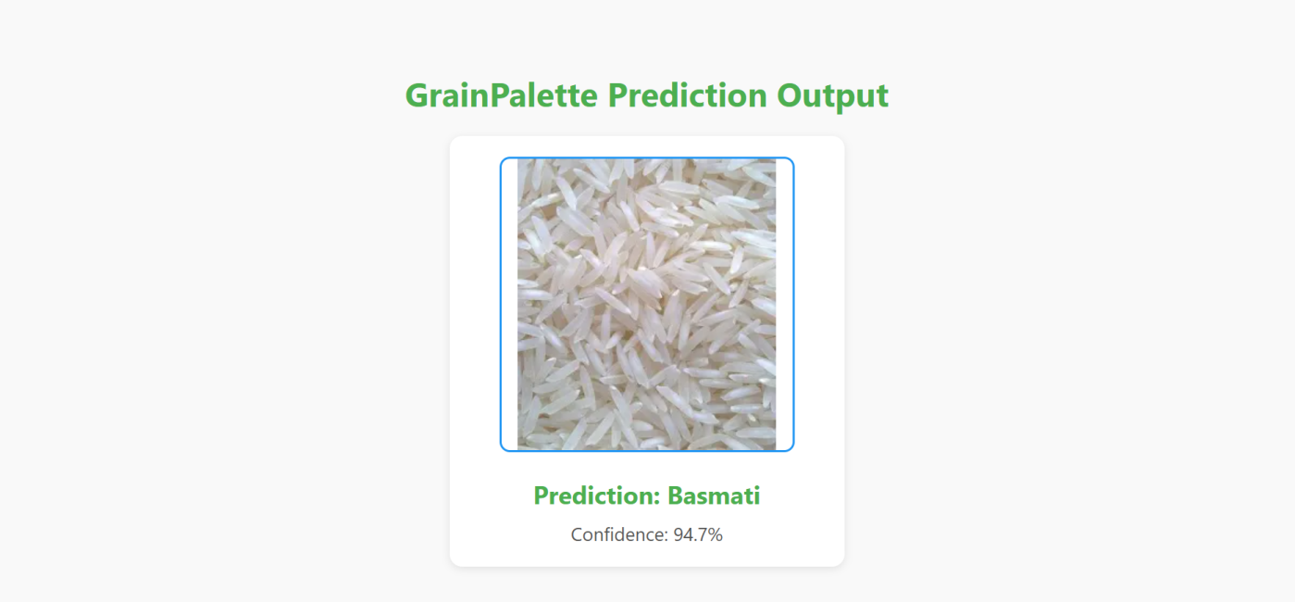

## Description:

GrainPalette is an AI-powered rice grain classification system that uses deep learning and transfer learning techniques to accurately identify different types of rice from images. By uploading a photo of a rice grain, users receive instant predictions about the rice variety along with confidence scores. This tool aids farmers, researchers, and gardeners in making informed decisions related to cultivation practices, contributing to more efficient and sustainable agriculture.

## Displayed Output:

**Prediction:** Basmati  
**Confidence:** 94.7%

The system analyzes the uploaded rice grain image and predicts the most likely rice variety along with a confidence score. The confidence score reflects how certain the model is about its prediction, helping users gauge the reliability of the result.